भारत मौसम विज्ञान विभाग |  | India Meteorological Department
Monday 25th May 2026 (04th Jyaistha 1948 Saka)
Summary of observations recorded at 0830 hours IST:.
.
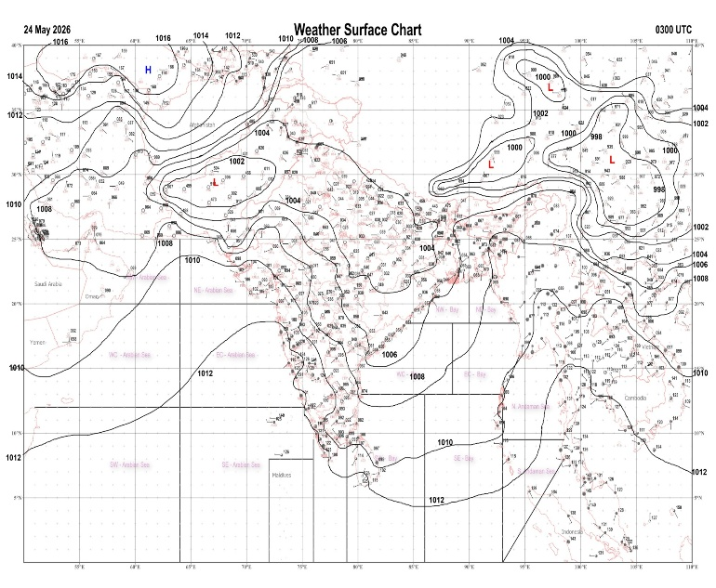 | 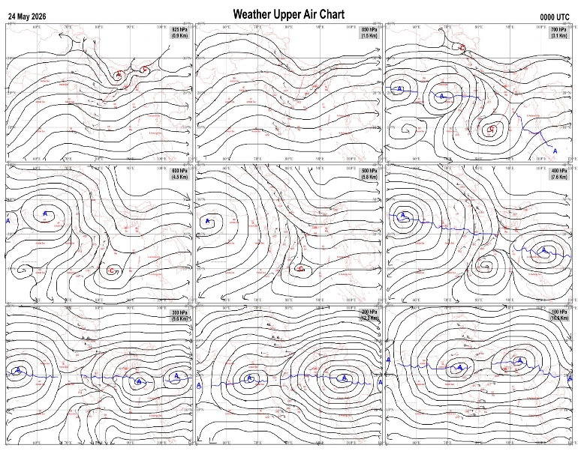
Fig.1. Analysed surface chart based on 03z observation | Fig.2. Analysed upper air chart based on 00z observation
V.K.Shripad
Scientific Officer ‘I’
CR & S Office, Pune  Issued at 1245 hrs. IST |  | Weather Forecasting Division  CR&S, Pune

Indian regions | Realised rainfall (chief amount in cm during past 24 hrs):
Table-2 Forecast / warnings (distribution of rain / thundershowers) for 7 days (valid from time of origin upto 0830 hrs IST of next day)
Sr N. |  | Sub-division Name | Day 1 | Day 2 | Day 3 | Day 4 | Day 5 | Day 6 | Day 7 | Sr. No. | Sub-division Name | Day 1 | Day 2 | Day 3 | Day 4 | Day 5 | Day 6 | Day 7
 |  |  | 25 May | 26 May | 27 May | 28 May | 29 May | 30 May | 31 May |  |  | 25 May | 26 May | 27 May | 28 May | 29 May | 30 May | 31 May
 | 1 | Andaman Nicobar Islands |  |  |  |  |  |  |  | 19 | west Madhya Pradesh
 | 2 | Arunachal Pradesh |  |  |  |  |  |  |  | 20 | east Madhya Pradesh
 | 3 | Assam-Meghalaya |  |  |  |  |  |  |  | 21 | Gujarat region
 | 4 | Nagaland-Manipur-Mizoram-Tripura |  |  |  |  |  |  |  | 22 | Saurashtra and Kutch
 | 5 | Sub Him West Bengal/Sikkim |  |  |  |  |  |  |  | 23 | Konkan and Goa
 | 6 | Gangetic West Bengal |  |  |  |  |  |  |  | 24 | Madhya Maharashtra
 | 7 | Odisha |  |  |  |  |  |  |  | 25 | Marathwada
 | 8 | Jharkhand |  |  |  |  |  |  |  | 26 | Vidarbha
 | 9 | Bihar |  |  |  |  |  |  |  | 27 | Chhattisgarh
 | 10 | east Uttar Pradesh |  |  |  |  |  |  |  | 28 | Coastal Andhra Pradesh and Yanam
 | 11 | west Uttar Pradesh |  |  |  |  |  |  |  | 29 | Telangana
 | 12 | Uttarakhand |  |  |  |  |  |  |  | 30 | Rayalaseema
 | 13 | Haryana,Chandigarh and Delhi |  |  |  |  |  |  |  | 31 | Tamil Nadu, Puducherry and Karaikal
 | 14 | Punjab |  |  |  |  |  |  |  | 32 | Coastal Karnataka
 | 15 | Himachal Pradesh |  |  |  |  |  |  |  | 33 | North interior Karnataka
 | 16 | Jammu-Kashmir and Ladakh |  |  |  |  |  |  |  | 34 | South interior Karnataka
 | 17 | west Rajasthan |  |  |  |  |  |  |  | 35 | Kerala and Mahe
 | 18 | east Rajasthan |  |  |  |  |  |  |  | 36 | Lakshadweep
Legends: D = Dry I =isolated S = Scattered F = Fairly widespread W = Widespread #= heavy to very heavy rain at a few places with extremely heavy rain at isolated places+++= heavy rain at a few places with very heavy rain at isoIated places++= heavy to very heavy rainfall @=isolated exceptionally heavy rainfall+ = heavy rain ●/*= rain or snow ♦ = very light rain ≡=fog = thunderstorm with lightning =Squall / Gusty / gale / strong wind -=cold wave/cold day + = heat wave/warm night/hot and humid weather =Duststorm =ground frost = Hail.

Fig. 4: Districtwise warnings for five days for Maharashtra State
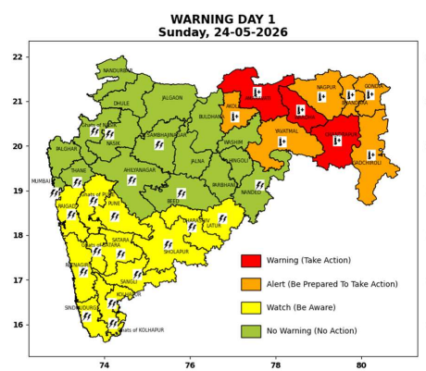 | 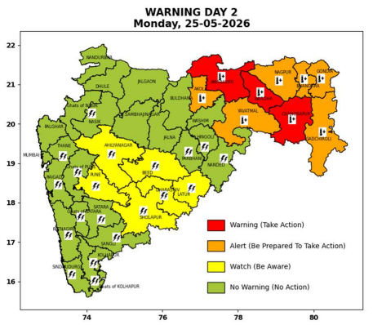 | 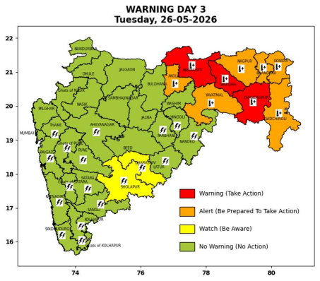 | 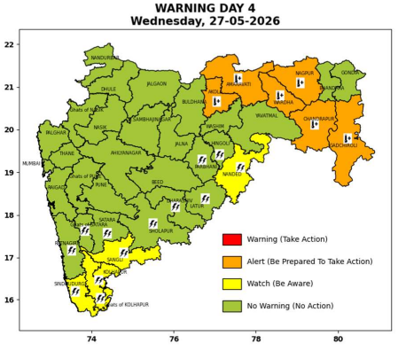 | 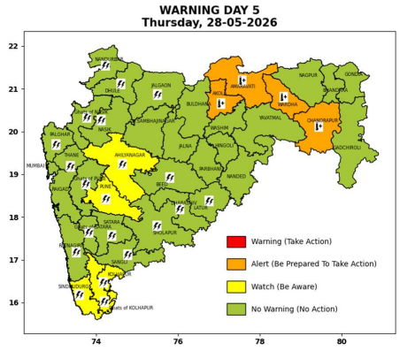

Pune, Lohegaon and Pashan observations at 0830 hrs. IST of Today
 | Temperature (°C) |  |  |  |  | Humidity (%) |  |  |  | Rainfall (mm)
 | Max.  past  24 hrs | Dep.  from  normal | Min.  past  24 hrs. | Dep.  from  normal | Dry  Bulb | At 0830 hrs. IST | Dep.  From  normal | At 1730  hrs. IST of ‘y’day | Dep.  from  normal | Past  24 hrs. | Since  1st March | Dep.  from  normal
PNE | 34.9 | -1.7 | 24.2 | 0.5 | 28.0 | 71 | 8 | 58 | 18 | 0.0 | 106.1 | 69.0
PSN | - | - | 22.0 | - | 27.4 | 78 | - | - | - | 0.0 | - | -
LHG | 35.6 | -0.4 | 25.0 | 4.0 | 28.6 | 74 | 11 | 55 | 16 | 0.0 | 107.6 | 61.1

 |  |  |  |  |  |  | Local (Pune and neighbourhood) forecast
Max./Min. Temperature (°C) |  |  |  |  |  |  |  |  | Weather
Date | Pune | Pashan | Lohegaon | Chinchwad | Lavale | Magarpatta | NDA | Koregoan park
25/05/26 | 36 / 24.2* | 36 / 22.0* | 37 / 25.0* | 35 / - | 35 / - | 39 / - | 35 / 23.2* | 37 / - | Mainly clear sky becoming partly cloudy sky towards afternoon or evening. Thunderstorm with lightning, light rain very light.
26/05/26 | 36 / 25 | 36 / 25 | 37 / 26 | 35 / 26 | 35 / 23 | 39 / 25 | 35 / 25 | 37 / 27 | Mainly clear sky becoming partly cloudy sky towards afternoon or evening. Thunderstorm with lightning, light rain very light.
27/05/26 | 37 / 25 | 37 / 25 | 38 / 26 | 36 / 26 | 36 / 23 | 39 / 25 | 36 / 25 | 38 / 27 | Mainly clear sky becoming partly cloudy sky towards afternoon or evening.
28/05/26 | 37 / 26 | 37 / 26 | 38 / 27 | 36 / 27 | 36 / 24 | 40 / 26 | 36 / 26 | 38 / 28 | Mainly clear sky becoming partly cloudy sky towards afternoon or evening.
29/05/26 | 38 / 26 | 38 / 26 | 39 / 27 | 37 / 27 | 37 / 24 | 40 / 26 | 37 / 26 | 39 / 28 | Mainly clear sky becoming partly cloudy sky towards afternoon or evening.
30/05/26 | 38 / 26 | 38 / 26 | 39 / 27 | 37 / 27 | 37 / 24 | 40 / 26 | 37 / 26 | 39 / 28 | Mainly clear sky becoming partly cloudy sky towards afternoon or evening.
31/05/26 | 38 / 26 | 38 / 26 | 39 / 27 | 37 / 27 | 37 / 24 | 40 / 26 | 37 / 26 | 39 / 28 | Mainly clear sky becoming partly cloudy sky towards afternoon or evening.
Rainfall Distribution |  |  |  |  | Rainfall Categories | Rainfall (mm) | Cloud condition |  | Rainfall Intensity | Range
Widespread (W) | 76-100% |  |  |  | Very Light rain | Trace to 2.4 mm | Mainly clear sky | 1-2 oktas | Light Spell | 1 cm/hr
 |  |  |  |  | Light rain | 2.5 to 15.5 mm | Partly cloudy sky | 3-4 oktas | Moderate Spell | 1-2 cm/hr
Fairly Widespread (FW) | 51 – 75% |  |  |  | Moderate rain | 15.6 to 64.4 mm | Generally cloudy sky | 5-7 oktas | Intense Spell | 2-3 cm/hr
Scattered (S) | 26 – 50% |  |  |  | Heavy rain | 64.5 to 115.5 mm | Overcast | 8 oktas | Very Intense Spell | 3-5 cm/hr
Isolated (I) | 1 – 25% |  |  |  | Very heavy rain | 115.6 to 204.4 mm |  |  | Extremely Intense Spell | 5-10 cm/hr
Dry (D) | No Rain |  |  |  | Extremely heavy rain | ≥ 204.5 mm |  |  | Cloudburst | > 10 cm/hr
Probability Terms in %: |  |  |  |  | Heavy snow | 6.5 to 11.5 cms water equivalent of rain
unlikely | < 25 |  |  |  | Very heavy snow | 11.6 to 20.4 cms water equivalent of rain
likely | between 25 50
very likely | between 51 75
most likely | >75
* = realized temperature
Mumbai (Colaba) |  |  |  | Nagpur (AP)
Date 2026 | T max °C | T min °C | Weather | T max °C | T min °C | Weather
25/05/26 | 34 | 27 | Partly cloudy sky. | 45 | 29 | Heat Wave.
26/05/26 | 35 | 27 | Clear sky. | 45 | 29 | Heat Wave.
27/05/26 | 35 | 27 | Clear sky. | 46 | 28 | Heat Wave.
28/05/26 | 34 | 27 | Clear sky. | 45 | 28 | Heat Wave.
29/05/26 | 34 | 27 | Clear sky. | 45 | 30 | Heat Wave.
30/05/26 | 34 | 27 | Clear sky. | 45 | 30 | Heat Wave.
31/05/26 | 34 | 27 | Clear sky. | 45 | 30 | Heat Wave.

